**Lab Report on  
Microprocessor and Assembly Language Lab  
  
  
Course Code: CSE 232  
Fall-2014**



**Submitted To:**Nasrin Akter  
Dept. of Computer Science & Engineering  
Faculty of Science & Information Technology

**Submitted by:**Syed Ahmed Zaki  
ID:131-15-2169  
Sec: B  
Dept. of CSE,FSIT

**Date of submission: 12, December 2014**

Contents

**Problem Page**Problem 1 2  
Problem 2 4   
Problem 3 7  
Problem 4 8  
Problem 5 9  
Problem 6 10  
Problem 7 11  
Problem 8 12

**Problem 1: The sum of 5 and 4 is 9**

**Solution:**.model small  
.stack 100h  
.data

m1 db "Enter two number: $"  
m2 db "The sum of $"  
m3 db " and $"  
m4 db " = $"

.code

main proc

mov ax,@data  
 mov ds,ax

lea dx,m1  
 mov ah,9  
 int 21h

mov ah,1  
 int 21h

mov bl,al  
  
 mov ah,1  
 int 21h

mov bh,al

mov ah,2  
 mov dl,0dh  
 int 21h

mov dl,0ah

int 21h

lea dx,m2  
 mov ah,9  
 int 21h

mov ah,2  
 mov dl,bl  
 int 21h

mov ah,9   
 lea dx,m3  
 int 21h

mov ah,2  
 mov dl,bh  
 int 21h

lea dx,m4  
 mov ah,9  
 int 21h

sub bl,30h

sub bh,30h

add bl,bh  
 add bl,30h

mov ah,2  
 mov dl,bl  
 int 21h

mov ah,4ch  
 int 21h

main endp   
end main  
**Output:**

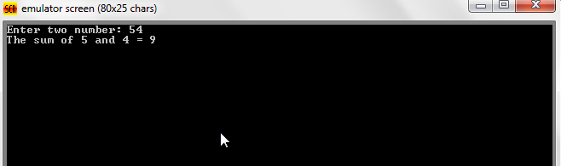

**Problem 2: Write a program to display the left margin:  
Enter seven initial:12345  
1  
2  
3  
4  
5  
  
Solution:**.model small  
.stack 100h  
.data

m1 db "Enter five initial:$"  
.code

main proc

mov ax,@data  
 mov ds,ax

lea dx,m1  
 mov ah,9  
 int 21h

mov ah,1  
 int 21h  
 mov bl,al

mov ah,1  
 int 21h   
  
 mov bh,al  
  
 mov ah,1  
 int 21h

mov cl,al

mov ah,1  
 int 21h

mov ch,al

mov ah,1  
 int 21h  
 mov dh,al  
  
 mov ah,2  
 mov dl,0dh  
 int 21h  
 mov dl,0ah  
 int 21h

mov ah,2

mov dl,bl

int 21h

mov ah,2

mov dl,0dh

int 21h

mov dl,0ah

int 21h

mov ah,2  
 mov dl,bh  
 int 21h

mov ah,2  
 mov dl,0dh  
 int 21h  
 mov dl,0ah  
 int 21h

mov ah,2  
 mov dl,cl  
 int 21h   
 mov ah,2

mov dl,0dh  
 int 21h  
 mov dl,0ah  
 int 21h

mov ah,2  
 mov dl,ch  
 int 21h

mov ah,2  
 mov dl,0dh  
 int 21h  
 mov dl,0ah  
 int 21h

mov ah,2  
 mov dl,dh  
 int 21h

mov ah,4ch  
 int 21h

main endp   
end main

**Output:**

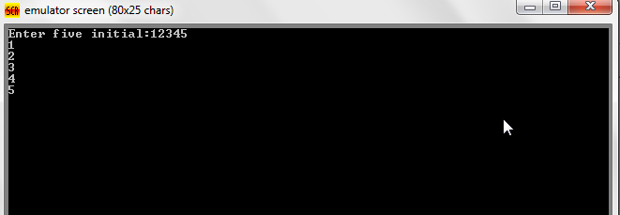

**Problem 3: Suppose AL and BL contain two number,Display the one that comes last in the sequence.  
  
Solution:**.model small  
.stack 100h  
.code

main proc  
 mov al,68  
 mov bl,65  
  
 cmp al,bl  
jg d1  
jmp d2  
  
 d1:  
mov ah,2  
mov dl,al  
int 21h  
jmp exit  
  
d2:  
 mov ah,2  
 mov dl,bl  
 int 21h

exit:  
mov ah,4c  
 int 21h

main endp  
end main  
 **Output:  
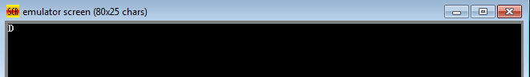**

**Problem 4: AL and BL contain two characters. Display the last character.**

**Solution:**  
.model small  
.stack 100h  
.code

main proc  
  
 mov al,'A'  
mov bl,'M'

cmp al,bl  
 jg d1  
 jmp d2

d1:  
 mov ah,2  
 mov dl,al

int 21h  
jmp exit

d2:  
 mov ah,2  
 mov dl,bl  
 int 21h

exit:  
 mov ah,4ch  
 int 21h

main endp  
 end main  
**Output:**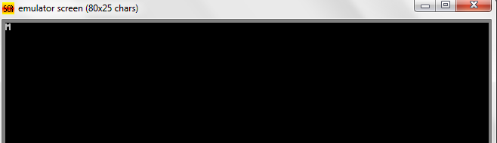

**Problem 5:If AL contain number display “n” ; If AL contain character display “c”**   
  
**Solution:**  
.model small  
.stack 100h  
.code  
main proc

mov ah,1  
 int 21h

mov bl,al

mov ah,2  
 mov dl,0dh  
 int 21h  
 mov dl,0ah  
 int 21h

cmp bl,'1'  
 je print_number_n  
 jmp print_character_c

print_number_n:  
 mov ah,2  
 mov dl,'n'  
 int 21h  
 jmp exit   
  
 print_character_c:  
 mov ah,2  
 mov dl,'c'  
 int 21h

exit:  
 mov ah,4ch  
 int 21h

main endp  
end main

**Output:**

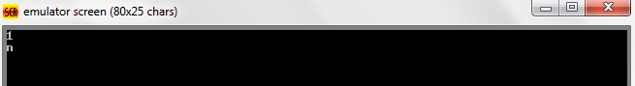  
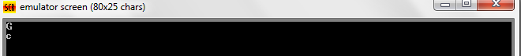

**Problem 6: Read a character and if it is lowercase letter, Display it.  
Solution:**

.model small  
.stack 100h  
.code  
  
main proc

mov ah,1  
 int 21h

mov bl,al

cmp bl,'a'  
 jnge end_if  
 cmp bl,'z'  
 jnge end_if

mov ah,2  
 mov dl,bl  
 int 21h

end_if:  
  
 mov ah,4ch  
 int 21h

main endp  
end main  
 **Output:**

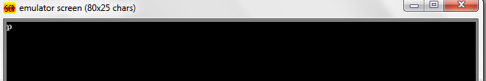

**Problem 7:**

**Write a count – controlled loop to display a row of 60 stars.  
  
Solution:**

.model small  
 .stack 100h  
.code

main proc  
mov cx,60  
mov ah,2  
mov dl,'*'

count:

int 21h

loop count

main endp

end main

**Output:  
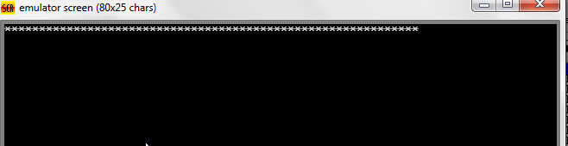**

**Problem 8:**

**Prompt the user to enter a line of text. On the next line, display the capital letter entered that comes first alphabetically and the one that comes last. If no capital entered, display “No capital letters”.   
  
Solution:**.model small  
.stack 100h  
.data  
prompt db 'Type a line of text',0dh,0ah,'$'  
nocap_msg db 0dh,0ah,'No capitals $'  
cap_msg db 0dh,0ah,'First Capital = '  
first db '|'  
 db ' Last Capital = '  
last db '@ $'

.code  
main proc  
   
;initialize ds

mov ax,@data

mov ds,ax

;display opening message

mov ah,9 ;display string function  
 lea dx,prompt ;get opening message  
 int 21h ;display it

;read and process a line of text

mov ah,1 ;read a character function  
 int 21h ;char in dl

while_:  
 ;while a character is not a carriage return do  
 cmp al,0dh ;CR?  
 je end_while ;yes,exit

;if character is a capital letter

cmp al,'A' ;char >='A'?  
 jnge end_if ;not a capital letter  
 cmp al,'Z' ;char <= 'Z'?  
 jnle end_if ;not a capital letter

;then

;if character precedes first capital

cmp al,first ;char < first capital ?  
 jnl check_last ;no, >=

;then first capital = character

mov first,al ;FIRST=char

;end_if

check_last: ;char >last capital?

;if character follows last capital

cmp al,last ;char > last capital?  
 jng end_if ;no,<=

;then last capital=character

mov last,al ;last = char

;end_if

end_if:

;read a character

int 21h ;char in AL  
 jmp while_ ;repeat loop

end_while:

;display results

mov ah,9 ;display string function

;if no capitals were typed

cmp first,'|' ;first '|'  
 jne caps ;no display results

;then

lea dx,nocap_msg ;no capitals  
 jmp display

caps:

lea dx,cap_msg ;capitals

display:  
 int 21h ;display message

;end_if

;dos exit

mov ah,4ch  
 int 21h

main endp  
end main  
 **Output:  
